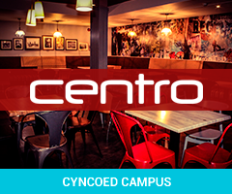
Internal Venue Booking Form for
Societies / Clubs / Students
Venue | Centro | Zen
Name of Event
Your name
Society Name or
Club Name
Position in Society
Mobile
Email
Day and Date of Event

(must allow at least 2 weeks before event)

Time:
Set up time
Event times
(to and from)

Nature of event

Plans to promote

Tickets

Printing / posters

Social media plans

Estimated Number of attendees
Will you have a guest speaker?
Yes No
If so you need to complete a guest speaker form and hand it in 30 days before your event.
What do you require from the venue?
- Full Space
- Private section
- Food
- Drinks
- Microphones
- Screen
- DJ (if providing own but need the equipment please state this)

Sign: |  | Date:
Once you have filled in this form, please email it to kdoherty@cardiffmet.ac.uk & Studentunion@cardiffmet.ac.uk or drop in a copy to the SU office

